**Project Title:** Deep Learning Visual E-Commerce Recommender

**Project Team:** Team Royals

**Team Members:** Wayne Nguyen, Hongcheng Jiang, Fei Wu, and Zhaobin Zhang

1. **Project Goal and Objectives**
2. Motivation

The world has become our oyster. Society has never been more connected with the help of the internet, instant messaging, the media, etc. Information and new ideas can now be readily available at our figure tips. This is great for the general purposed user, but with this information overload it lacks the individual touch. Individual taste, lifestyles, and especially fashion can be hard to express with our current level of technology. As we have it now, product recommendations are only based on click/purchased activities ignoring the visual content. This can have its limits as click activities can not encompass most of an individual taste.

1. Significance

To potentially fill in this technology gap, Team Royals purpose an application called “We-Recommend”. This of course will be based on the visual aspects of the individual wants and interests with support of their click activities to recommend products that are similar, interesting, and relevant to that individual. With our easy to use application, the individual can supply an image from any source. The image will then be processed with our deep learning algorithms (CNN architecture, supervised learning, object localization). Up-to-date, relevant, and individually tailored product recommendations will be suggested to the user that will be more accurate and useful than the standard we have now.

1. Objectives

An advantage with deep learning algorithms is that it does not suffer from ‘cold starts’ where very limited click information is known about the user. Deep learning algorithms have been proven to successfully run with small samples and provide accurate data to the user. Training data can be easily tested and filtered to fit an individual or even region. As the user keeps on using our application, its data-set will continue to grow and adjust to the individual as their taste and lifestyles changes over time.

1. System features

Our application will have an easy to use interface that first will allow them to sign-up and sign in. Once signed in, the user can import any images and tag any/none descriptions to them. A knowledge search bar will also be provided if the user doesn’t have any images to provide at that time. When a search or image is provided, the deep learning algorithms will process the information and another page will provide the relevant product recommendation results to the user. This will show a list of potential products, its accuracy, and suggested shopping stores/sites. We would hope in the future to also incorporate location-based technologies with the images to further refine the recommendation results. Other future scopes we can investigate with the power of deep learning visuals is food related materials and retrieving their corresponding recipes or at which restaurants serve that food. The possibilities can be endless with deep learning visuals and training data can be easily obtained to make this application more tailored to the individuals needs and interest.

1. **Related work**

Deep learning [3] has become a promising technique to perform various tasks, especially in image/video-based tasks. For examples, face recognition, classification and retrieval to name a few. In [1] a novel E-Commerce system has been proposed which is based on VGG-16 [2].

1. **Project plan**
2. Features/Requirements
3. Registration/Sign-in
4. Image importer with tags
5. Deep Learning Algorithm/API
6. Knowledge search bar
7. Result output page for product
8. Deep learning product suggestions
9. Product recommendation stores/sites
10. Easy to use UI
11. Location technologies/Future scope
12. Data-Sets
13. Flipkart Fashion
14. Street2Shop
15. Technologies
16. IDE: Pycharm, IntelliJ, Android Studio, WebStorm
17. Deep Learning: Clarifai API, Google Knowledge Search, VisNet, etc.
18. Database: MongoDB, AWS
19. Project Timeline
20. Proposal: 2/2/2018
21. Increment 1: 2/23/2018
22. Increment 2: 3/19/2018
23. Increment 3: 4/23/2018
24. Final Submission: 5/7/2018
25. Team Member Responsibility
26. Wayne Nguyen: Testing.
27. Hongcheng Jiang: Application/GUI design.
28. Fei Wu: Documentation and proposal drafting.
29. Zhaobin Zhang: Algorithm design and training.
30. ZenHub Burndown Chart and Task

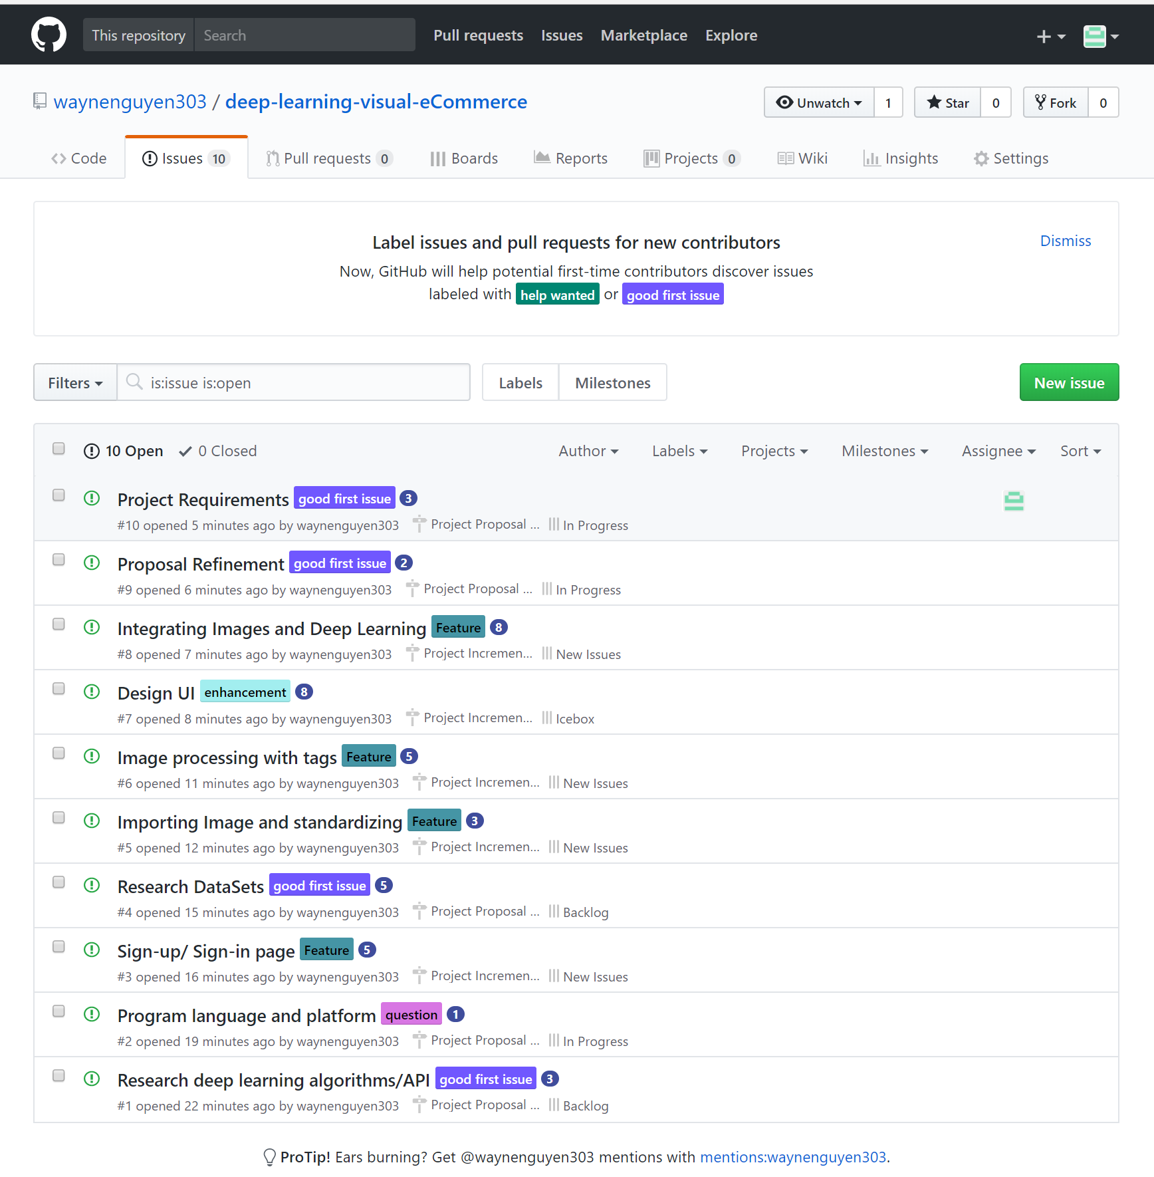

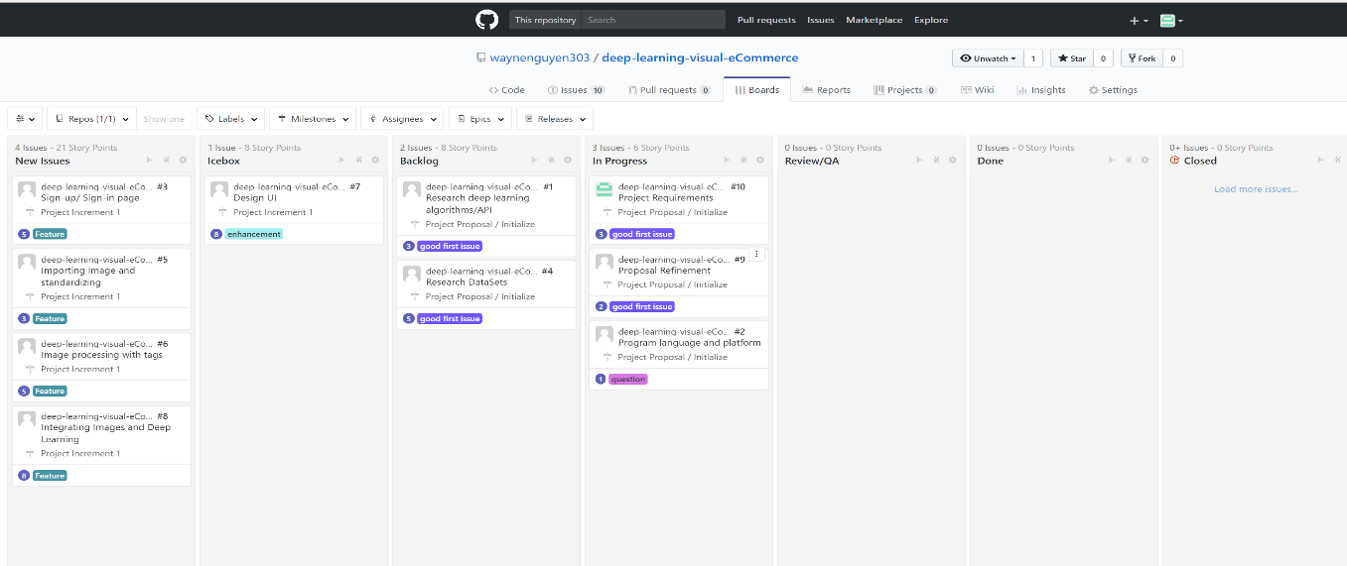

* ZenHub Board

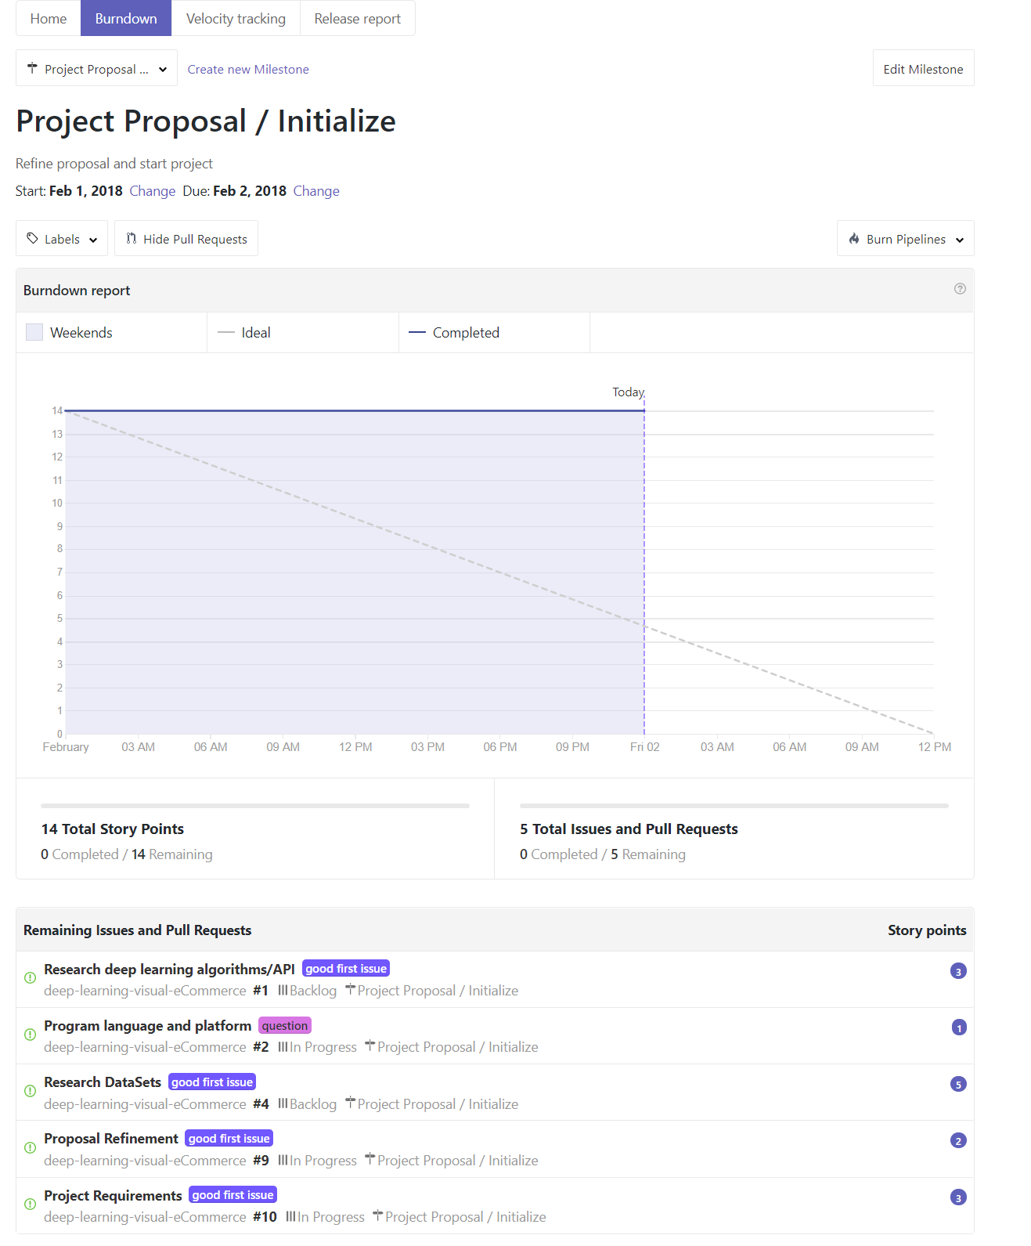

* Project proposal milestone

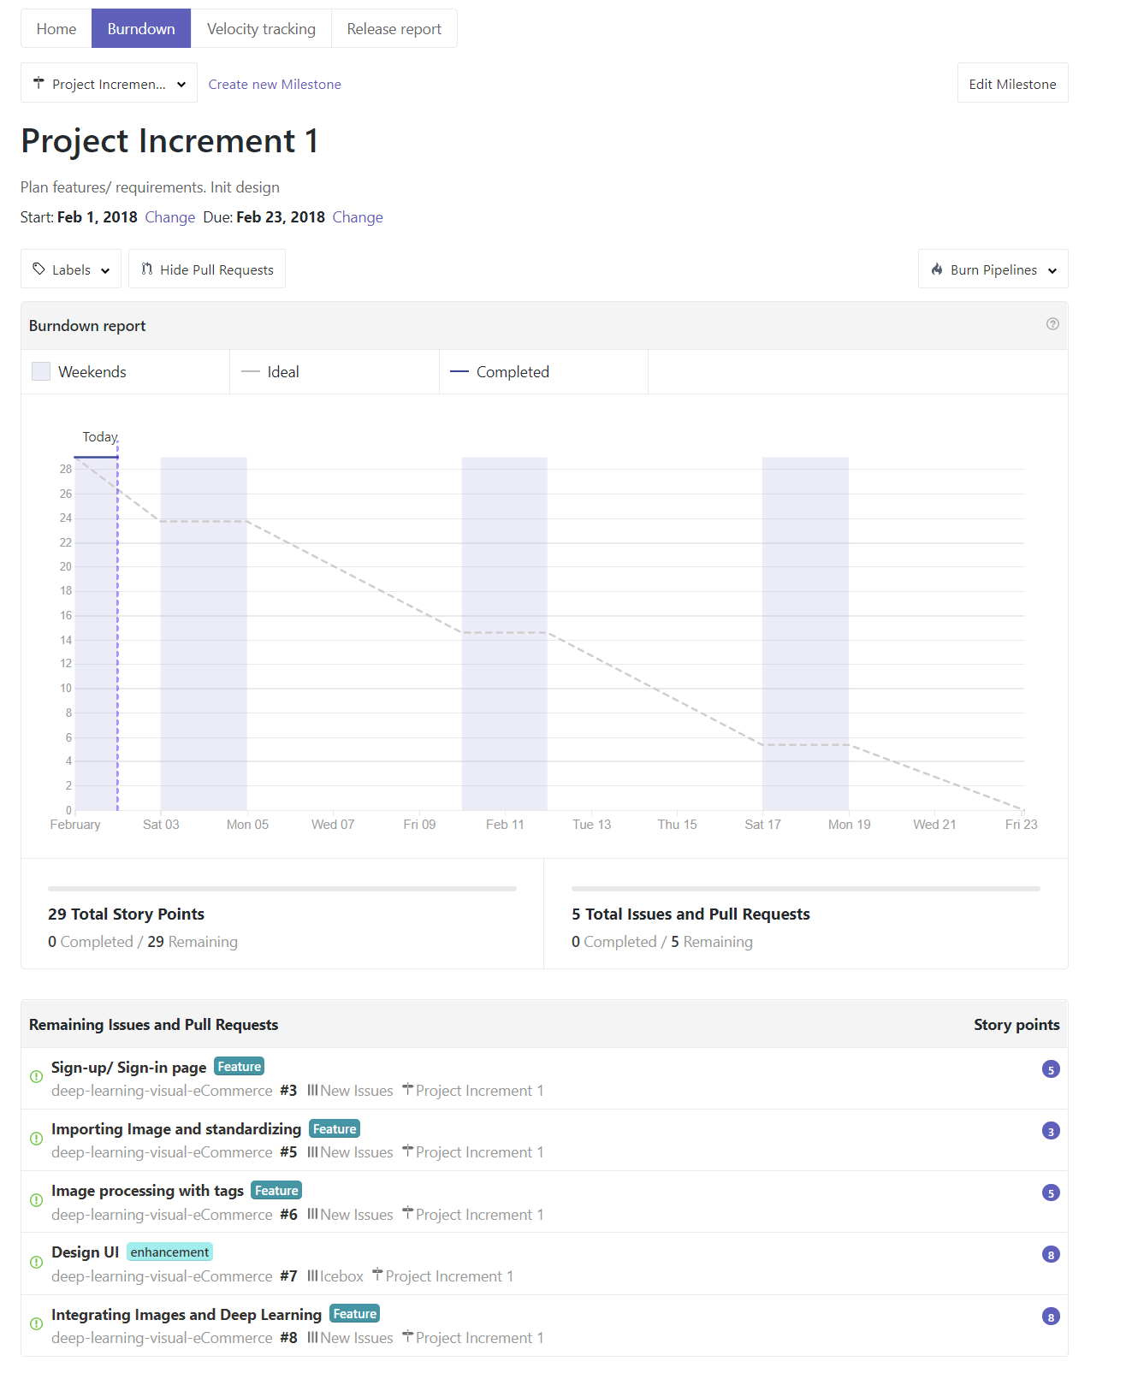

* Project increment 1 milestone

1. Devashish Shankar, Sujay Narumanchi, Ananya H A, *et al*, Deep Learning based Large Scale Visual Recommendation and Search for E-Commerce, https://arxiv.org/pdf/1703.02344.pdf, 2017.
2. Karen Simonyan, Andrew Zisserman, Very Deep Convolutional Networks for Large-Scale Image Recognition, CVPR, 2014.
3. Yann LeCun, Yoshua Bengio and Geoffrey Hinton, Deep Learning, Nature, 2015.